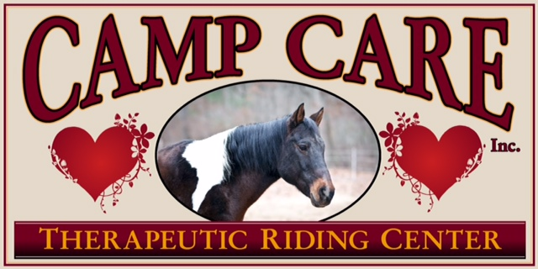
106 Route 66 E, Columbia CT 06237
PH: 860-228-8843 Fax: 860-228-2694
www.campcarekids.org

Dear Friend of Camp Care,

We welcome you to a new opportunity! We hope you would consider supporting us through a donation and/or sponsorship for our new big fundraiser this year for the
Camp Care Therapeutic Riding program!

On Saturday, October 6th, we’ll host our first ever, on site
Fall Fundraiser and Open House: Celebrating the Spirit of Camp Care.
We’ll host tours of the facilities, a giant indoor tag sale, a corral run for all abilities, and a “push ups for ponies” benefit! We will publicly thank recent corporate donors and volunteers who have done major work in our arena, trail and beyond.

We invite you to join us on October 6, 2018, any time between 9am and 3:30pm.
There will be something for everyone to enjoy.

We are so grateful for your support and we hope you will consider being a donor and/or sponsor of this new event. If you have any questions/concerns, you can contact Ruth Hartunian-Alumbaugh, Director of Development and Marketing at ruthHalumbaugh@gmail.com or 860-208-8783.

Please see attached sponsorship form and flyer. Check out our Facebook page for updated information. https://www.facebook.com/events/412580245815287/

Thank you!

Sincerely,

Laureen Moran, Camp Care CEO

The Camp Care mission is to help children and individuals with special needs reach their highest levels of potential in physical and cognitive function while enhancing self-esteem and emotional growth.

~ Celebrating the Spirit of Camp Care – Fall Fundraiser 10/6/18 ~
Celebration Donation
Name:
Email:
(Optional) Business name:
Business address:
Phone:
(Optional) In honor of:
Amount:
Payment form:

***********************************************************************

Spirited Sponsorship
_____$500 Event Sponsor: Signage at the event. Announced throughout the event. Listed on website, social media, at the event, in press releases, on the radio, and beyond. Opportunity to speak at the event.
_____$250 Volunteer Sponsor: Providing lunch for volunteers during the event, recognition at the event, in press releases, on the radio, and beyond. Volunteers are critical for success in our Camp Care Riding Program!
_____$100 Fan sponsor: yard sign at the event around corral run and push ups for ponies event. Event and social media.

Name:
Email:
(Optional) Company name:
Address:
Phone:
Form of Payment:

Please send this form and donation/sponsorship check (made out to Camp Care) to:
Camp Care Riding Program
106 Route 66 East
Columbia CT 06237

** Sponsorship must be received by 9/15/2018 to receive above benefits**

